**CS 570 Software Testing**

# HOP01C – Apache Maven in VSCode

1/31/2019 Developed by Sam Chung

School of Technology & Computing (STC)

City University of Seattle (CityU)

**Caution**

* If you already finished this module through any CityU Technology Institute (TI) courses,  
  just skim this module and skip it.
* Some version numbers may not match with the newly released ones.  
  If so, stay with the most recent ones.
* We target Windows OS. So, Mac may have different options.
* We cannot explain every steps. This cookbook always needs your own creative judgement.

**Learning Outcomes**

* Learn how to install the Apache Maven build tools on your local development environment.

**Install Apache Maven**

1. Visit Apache Maven 3.6.0 at <https://maven.apache.org/download.cgi>

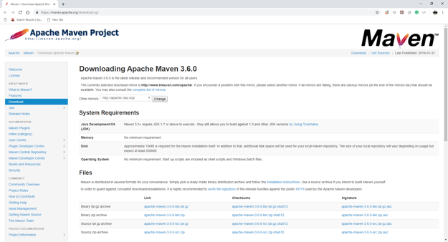

1. Download a correct version for you.   
   For my Windows laptop, I chose a binary zip archive, “apache-maven-3.6.0-bin.zip”
2. Follow the installation guidelines of Apache Maven.  
   Visit “Installing Apache Maven” at <https://maven.apache.org/install.html>

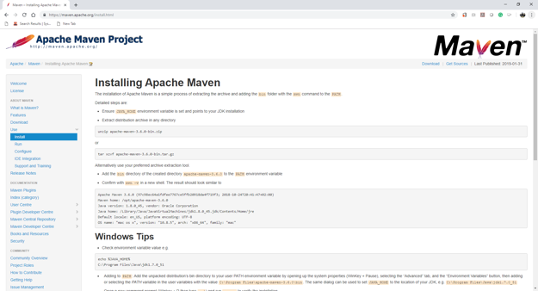

1. Unzip “apache-maven-3.6.0-bin.zip”

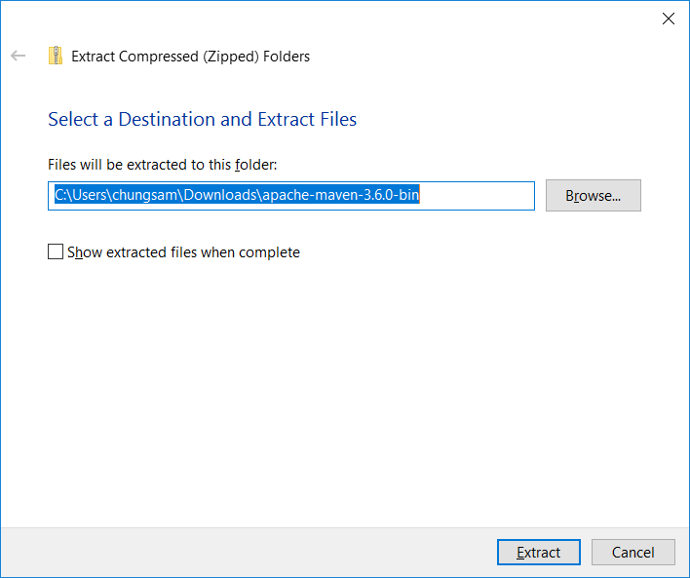

1. Open the unzipped file.  
   Move to “apache-maven-3.6.0” directory.

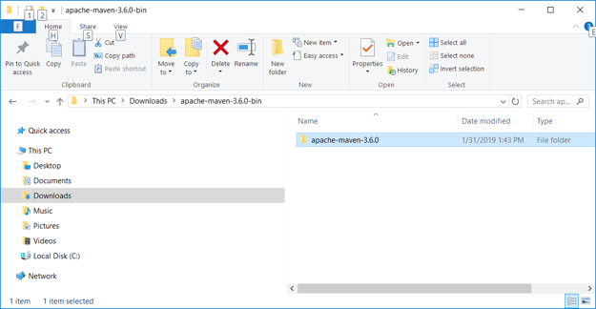

1. Move the “apache-maven-3.6.0” to “C:\Program Files”

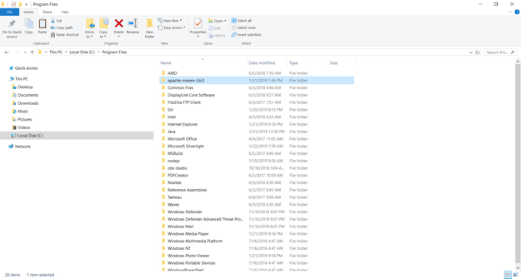

1. Find the bin directory of Apache Maven – “C:\Program Files\apache-maven-3.6.0\bin”

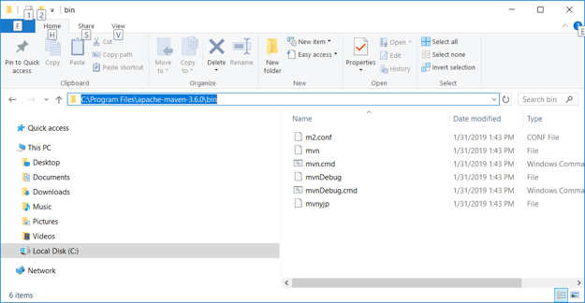

1. Open your terminal (Windows: Windows + R, then “cmd”) (MacOS: Command + Spacebar, then “terminal”)
2. Check the “JAVA_HOME” environmental value.  
   >echo %JAVA_HOME%

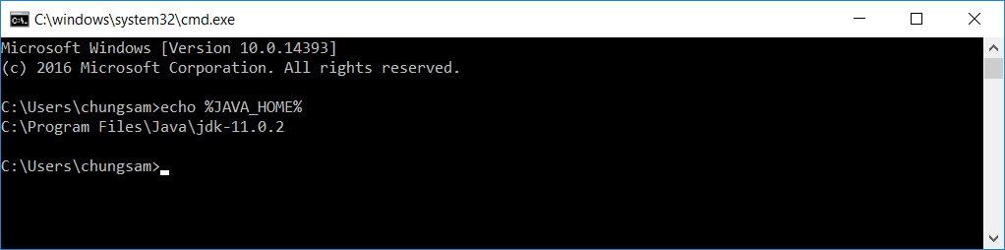

1. Set up the “Path” for Apache Maven.  
   Assume that you use a Windows platform.
   1. Right click “Windows” icon  from your start menu bar.
   2. Select “System” menu item.
   3. On the Advanced tab, select Environment Variables.
   4. Select the “Advanced system settings” tab.

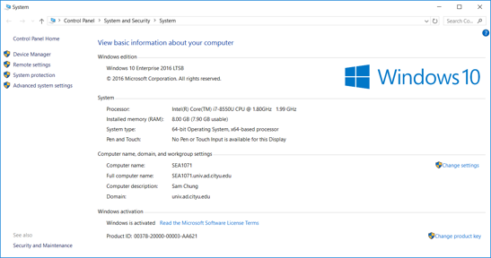

* 1. Select the “Environment Variable ….” Button.

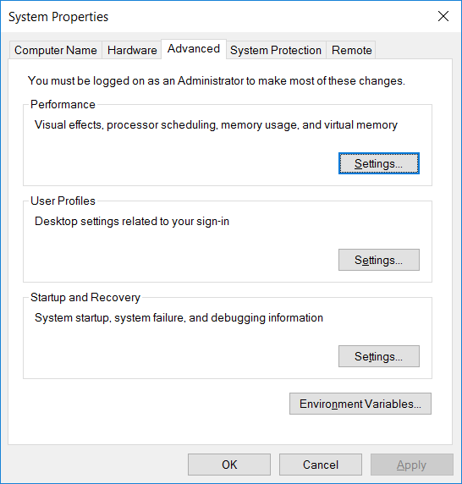

* 1. Edit the “Path” of the “System variables” to add the bin directory of Apache Maven.  
     Add a new path to the list.

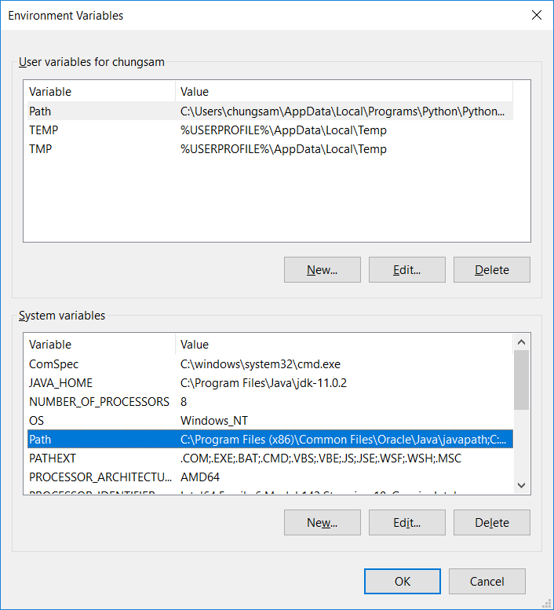

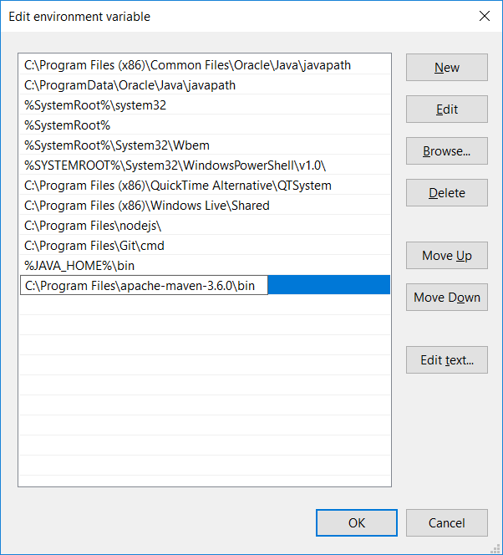

1. Test whether the Apache Maven was correctly installed or not.
   1. Open your terminal (Windows: Windows + R, then “cmd”) (MacOS: Command + Spacebar, then “terminal”)
   2. Type “mvn –v” or “mvn --version”

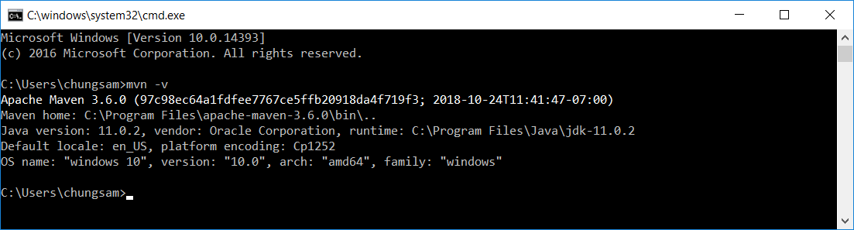

**Questions:**Answer each question.   
Show a good reference(s) to support your answer.

1. Why do you install Apache maven?   
     
   Maven allows us to define required files and when the project is building, the reqired files will be downloaded.